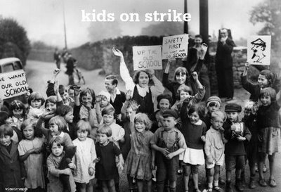
Strike Sign Builder – Analytics

These are the feedback points that are “trending,” coming out of a careful review of the 5th graders’ “first draft” work on their sign-builders.

Trending: Already Good

- Some argumentative claims are properly generalized between detail of the evidence and the overall position that the kids are justified by going on strike [Suren, Kimberly]

- Some evidence is factual [Jacob, JonJaira]

- Some reasoning carefully conforms to its function and purpose [Morgan, Suren]

Trending: Can Be Improved

- Some claims are not full ideas [Bridget]

- Claims should be limited to a single reason [Jacob, Beisha]

- Claims should be located between the detail of the evidence and the generalization of the position [Haven]

- Formulating a claim should always be as precise as possible [Morgan]

- Evidence should be factual, not descriptive [Aisha, Annya].

- Evidence should include a page number, and should quote when it is relying on the authority of the text [Olivia]

- Reasoning should explain why it is that the factual evidence proves the claim. It should interpret the facts in a way that shows that they support the claim [JonJaira]

- Counter-arguments should be limited to one reason that the strike is not justified [Haven]

- Slogans are right now rarely rebuttals of the counter-argument, though they need to be. People got the “slogan” part right (they are short, they often rhyme) but not the “rebuttal” part (they have to respond to and try to refute the counter-argument) [Santiago]. A model: “The Journal may be losing lots of money, but we’re losing limbs and that’s not funny.” [Or Aisha’s: “Raise our pay, and we will stay!”]

