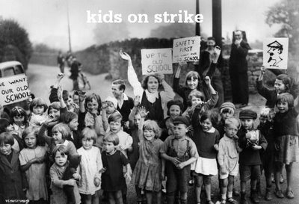
Kids on Strike – Jigsaw Tables Peer Evaluation

Overview

In a jigsaw-like format, you will be placed at a table with six students, one representing each of the kids strikes that we’ve studied in this unit. At these tables, each student will present on their strike. There should be four sections in each presentation: information on the strike, the best argument for the strike, the strike’s rebuttal slogan, and questions and answers (Q. and A.). Each presentation should be brief, about four minutes, and the jigsaw table presentations will last 25 minutes. But, there will be two of them, so you will give two presentations, at two separate jigsaw tables, and you will listen to presentations from two separate sets of students presenting on each of the other five kids strikes. You will need to complete a peer evaluation form for each of the jigsaw tables.

Information on the Strike
Name of the Kids Strike
Name of Presenter
Information Summary

Response and Rating

Argument for the Strike
Name of the Kids Strike
Summary of Argument for the Strike

Response and Rating of Argument for the Strike

Rebuttal Slogan
Name of the Kids Strike
Summary of Rebuttal Slogan

Response and Rating of Rebuttal Slogan

