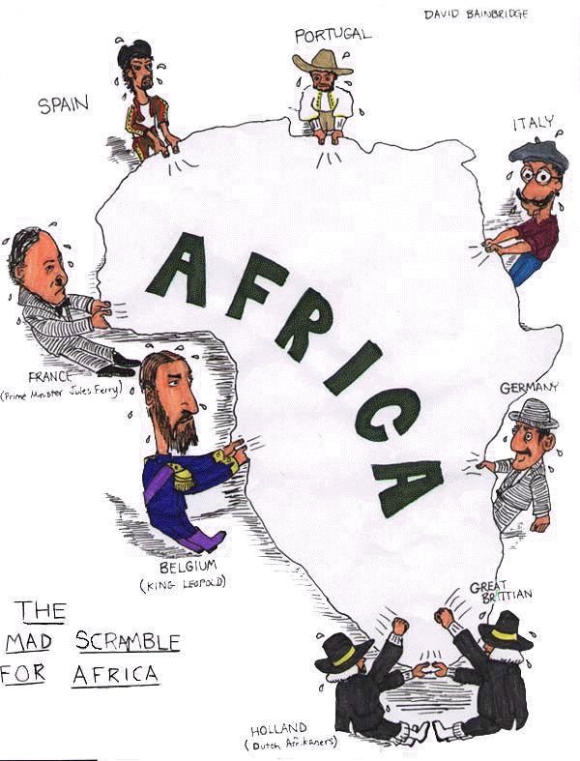

Colonialism and Post-Colonialism in Africa
IMPLEMENTATION PLAN

Day 1
Introduction to the unit: Colonialism and Post-Colonialism in Africa, the debatable issue, and
Table Debates
Vocabulary Crowd Sourcing Activity

Day 2
Distribute Argument-Based Reflection Questions
Screen “European Colonialism in Africa by Year”
Screen “A Brief History of Colonialism in Africa” twice.
Pair students to answer questions in writing.
In between screenings, review questions.
Share out and discuss.

Day 3
Distribute “White Man’s Burden” and read three times. The first time read it for the students, the second time chorally, the third time ask for three volunteers to break it up.
Define difficult language in between readings.
Review questions in between readings.
Same pairs of students should answer questions in writing.
Share out and discuss.

Day 4
Remind students of debatable issue.
Distribute argument builder and counter-argument builder models.
Provide direct instruction on the performance criteria for the use of evidence: alignment,
credibility, sufficiency, and reasoning.
Discuss the ways that the models demonstrate high performance on each criterion.
Have students quick-write manufactured evidence for the model claims.
Discuss student work, in relation to evidence criteria.
Assign students teams and sides for the Table Debates.

Day 5
Distribute documents.
Model responses on the first two documents: focused instruction, guided instruction
Have students work in their teams on the questions.

Day 6
Complete team-responses to the questions.
Share our and discuss student work.
Link student work to the criteria for the use of evidence
Collect and formatively assess team-responses.

Day 7
Review questions before screening “Africa: States of Independence”
Screen “Africa: States of Independence,” stopping when necessary to discuss questions.
Teams should be completing their responses to the argument-centered questions during the
screening.

Day 8
Complete the screening of “Africa: States of Independence,” continuing to stop when necessary to
discuss questions.
Share out and discuss responses.
Collect and formatively assess team-responses.

Day 9
Screen “What If Africa Was Never Colonized” twice.
In between, review argument-centered questions.
Conduct classroom-wide discussion of the questions.

Day 10
Screen “Heart of Darkness Summary”
Read Heart of Darkness excerpts twice, once by you, once by volunteers (one per excerpt)
Pair each team against a team from the opposite side.
Have four-person groups discuss argument-centered questions on Heart of Darkness.
Share out.
Assign each team: formulate two argumentative claims for their position for Monday.

Day 11
List out argumentative claims on each side.
Discuss claims on the basis of the performance criteria: focus, clarity, separateness, directedness.
Supplement list of claims with prepared list.
Begin argument building.

Day 12
Continue and complete first draft of argument building.
Submit argument builders for formative assessment and feedback.

Day 13
Post Table Debate matches (two per team).
Provide feedback on argument builders.
Have students revise their argument builders.
Preview arguments for their debate opponents.

Day 14
Supervise counter-argument building.
Orient students on Table Debates format and on the use of the flow sheet.
Day 15
Conduct Table Debates.
Showcase a leading Table Debate.
Collect and formatively assess flow sheets.
Assign argument essay, using templates.

