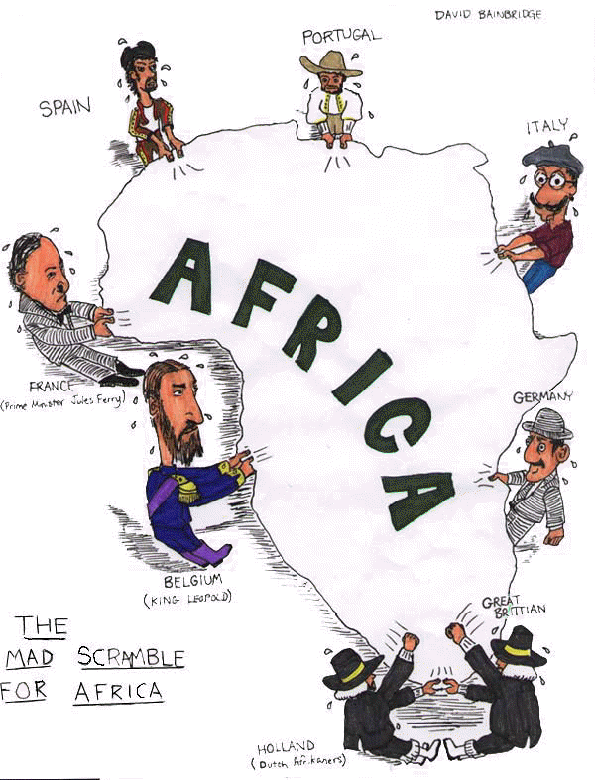

Colonialism and Post-Colonialism in Africa
VOCABULARY CROWD-SOURCING

Method and Procedure

In Vocabulary Crowd-Sourcing, you begin by putting the vocabulary terms up on butcher or chart paper around the room, with lines under the terms. Put one term on each piece of butcher paper or large piece of chart paper. Then, tell students that they should put one bullet point that represents what they know about that term, or how they would define that term, under two of the terms around the room. So every student should write one bullet point for each of two terms. Then, go through what they come up with, removing what's inaccurate (by crossing it out) and circling what's both accurate and essential, and adding what is missing but needed (from your definitions).

Vocabulary Terms

African Nationalism

Bad Faith

Colonialism

Cultural Assimilation

De-colonialization

Economic Factors

Ethnicization

Exploit

Geopolitical

Humanitarian

Hypocrisy

Imperialism

Rapacious

