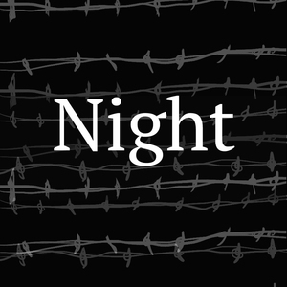
Night, by Elie Wiesel
Possible Claims and Counter-Claims

The debatable question for this unit is:

Did the Nazis succeed in committing deicide during the Holocaust, according to Night, by Elie
Wiesel?

These are possible argumentative claims and counter-claims, supporting and opposing the two overall positions on this debatable issue. They are aligned with the Selected Passages, though they are by no means exhaustive and students are encouraged to add to this list with their own ideas and formulations.

Position: The Nazis succeeded in committing decide during the Holocaust.

The Holocaust was so horrific that Jewish survivors could never come to an understanding of how it was allowed to happen.

Judaism allows for unsolvable mysteries and doesn’t demand answers from God.

Jews lost their ability to pray to a God who was silent to their prayers in the concentration camps.

God is always silent in response to prayers, which means that it was only in the extreme cruelty of concentration camps was prayer impossible.

The Holocaust dehumanized Jews, which means that the loss of faith was just one important way that it turned the lives of Jews upside-down.

This was true of the actual Holocaust survivors, but not of all Jews generally.

The just and merciful God that Judaism had worshipped would simply never let something as evil, cruel, and unjust occur.

Even though the Holocaust was awful, there have been other incidents of extreme brutality and injustice in history, including ones involving Jews, and Judaism has always carried on.

Position: The Nazis did not succeed in committing deicide during the Holocaust.

The Jewish victims of the Holocaust ultimately didn’t give up, but instead fought for their survival and for the survival of Judaism.

It’s true that they fought for their human survival, but this doesn’t mean that their religious belief survived.

Judaism recognizes the fundamental mystery of God’s presence and influence on this world and is comfortable worshipping through the questions to be asked of God.

But Judaism also identifies Jews as God’s Chosen People, because he protected them and delivered them from oppression, for instance in Egypt.

Victims of the Holocaust continued to look for and to recognize moral acts, the value of which depends on their continued belief.

Disbelief in a particular religion and that religion’s God is not the same as being amoral. Atheists, for instance, can have strong moral standards.

Jews blamed the Nazis and their supporters for the Holocaust, not God.

This is true, but they lost their faith because their God didn’t protect them in any way from the horrible, genocidal cruelty of the Nazis.

