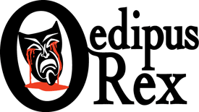

Possible Interpretive Positions

These are possible interpretive positions that students can take in response to the debatable issue in our unit on Oedipus Rex. If they do not find a position here that they wish to take, students can formulate their own position, but they should have that position reviewed to be sure it will work for our purposes.
Oedipus Is a Failed Leader
Because he is impulsive, self-centered, and unreliable, Oedipus is thoroughly unable to fulfill the
weighty responsibilities of kingship.
Oedipus Is Benighted
The most defining flaw in Oedipus’s character is that he is benighted – unknowledgeable,
uncurious, unwise – which makes his end so poetically fitting and admonitory.
Oedipus Is Violent
Sophocles depicts Oedipus as violent and murderous, folding his ending approximately into the
epigram, “An eye for an eye, a tooth for a tooth.”
Oedipus Actually Harbors Wrongful Desires
Underneath the appearance that he committed his crimes unintentionally, it is actually a more
credible reading to conclude that Oedipus had a hidden desire to murder his father and wed his mother.
Fate, not Oedipus, Is Culpable
Oedipus has his flaws, but nothing he does justifies the extremely cruel conditions that Fate in the
play crushes him under.

